BLAZE SPORTS INTEL
Business Plan
Operations, Technology & Management
Week 3 Assignment | GEB612
blazesportsintel.com

Austin Humphrey
Founder & CEO
December 2025
"Born to Blaze the Path Less Beaten"

Chapter 6: Operations
Blaze Sports Intel delivers championship-quality analytics for college baseball—one of only three revenue-generating NCAA sports—plus comprehensive coverage of college football, MLB, and NFL. Built on Cloudflare's serverless infrastructure with sub-50ms response times, we operate lean: automated data pipelines, zero server maintenance, and a mobile-first platform that scales from one user to one million without infrastructure changes. Our competitive advantage is simple: we cover what ESPN ignores, we do it faster, and we do it for a fraction of traditional media costs.

6.1 Company Overview
Blaze Sports Intel (BSI) is a sports analytics company headquartered in San Antonio, Texas, founded in 2025 by Austin Humphrey. The company provides real-time scores, complete box scores, and advanced analytics for college baseball—covering all 300+ Division I programs—along with comprehensive coverage of college football, Major League Baseball (MLB), and the National Football League (NFL).
The platform operates at blazesportsintel.com, built entirely on Cloudflare's edge network for sub-50ms global response times. BSI's mobile-first design ensures fans can access complete game data from anywhere, on any device. The company's brand identity—"Born in Memphis, rooted in Texas soil"—reflects founder Austin Humphrey's authentic connection to both regions and his philosophy that Texas represents "a covenant with oneself and the company you keep to never allow each other to stop dreaming beyond the horizon."
Source: blazesportsintel.com (December 2025)
Target launch for subscription services: Spring 2026, coinciding with the college baseball season.

6.2 Facilities
BSI will operate from a 500 square foot Class B office space in San Antonio's Near Northwest submarket. This submarket offers the highest concentration of office space in the San Antonio market while providing reasonable proximity to San Antonio International Airport and downtown.

Facility Costs
According to CommercialCafe's 2024 market analysis, San Antonio Class B office space averages $25.47 per square foot annually. For a 500 square foot space:
Cost Category | Annual Amount
Base Rent (500 sq ft × $25.47) | $12,735
Utilities (est. $125/month) | $1,500
Internet (business fiber, $150/month) | $1,800
Total Annual Facility Cost | $16,035
Source: CommercialCafe, "San Antonio Office Price per Sqft and Office Market Trends," 2024. Class B average: $25.47/sq ft.
The Near Northwest San Antonio submarket was selected based on CommercialCafe data showing it has the greatest concentration of available office space and competitive Class B rates at $25.39 per square foot. This location provides adequate space for the founder's workstation, content production equipment, and small meeting area while minimizing overhead during the startup phase.

6.3 Operational Processes
BSI's operations center on three core activities: data ingestion, content production, and platform maintenance. Each process is designed to maximize automation and minimize manual intervention, reflecting lean startup principles learned in AEL (Agile Enterprise Leadership).

Data Ingestion
Automated pipelines collect data from MLB Stats API, ESPN API, and proprietary sources via Cloudflare Workers. The platform employs triple-source verification for statistical accuracy—a competitive differentiator when covering programs that ESPN aggregators routinely mishandle. Data flows through D1 (SQL database) for structured storage and KV (key-value) for sub-millisecond caching.

Content Production
Peak production occurs February through June (college baseball season) and August through January (football seasons). The content calendar includes game previews published 24 hours before first pitch, real-time score updates during games, complete box scores within 30 minutes of game completion, and post-game recaps within 2 hours. Automated systems handle data aggregation while editorial content maintains the authentic, player-first voice that distinguishes BSI from corporate sports media.

Platform Performance
The serverless architecture on Cloudflare's edge network delivers sub-50ms response times globally. This eliminates traditional server maintenance, provides automatic scaling during traffic spikes (championship games, breaking news), and ensures 99.9% uptime without dedicated DevOps staff. The platform's mobile-first design—built with React and server-side rendering via Workers—ensures optimal performance across all devices.
Source: blazesportsintel.com technical specifications (December 2025)

6.4 Revenue Model & Profitability
BSI employs a tiered subscription model covering all four sports verticals: college baseball (primary), college football, MLB, and NFL.

Subscription Tiers
Tier | Price | Features
Free | $0/month | Live scores, basic standings, limited box scores, ad-supported
Pro | $29/month | Complete box scores, advanced analytics, all four sports, no ads, email alerts
Enterprise | $199/month | API access, bulk data exports, custom analytics dashboards, priority support, white-label options
This pricing structure positions BSI competitively against alternatives while capturing value across consumer (Free/Pro) and B2B (Enterprise) segments. The free tier drives user acquisition and advertising revenue; Pro converts engaged fans into paying subscribers; Enterprise captures value from programs, scouts, and media organizations.
Source: Blaze Sports Intel platform (blazesportsintel.com), December 2025. Platform covers college baseball, college football, MLB, and NFL with tiered subscription access.

Additional Revenue Streams
Beyond subscriptions, BSI generates revenue through targeted advertising (baseball equipment, training facilities, legal sports betting partners), content licensing to college programs and scouting services, and affiliate partnerships with relevant brands. The multi-sport coverage—college baseball, college football, MLB, NFL—expands the addressable market beyond the niche baseball-only model.

6.5 Competitive Advantages
BSI's operational model creates sustainable competitive advantages through technology architecture, authentic expertise, and market positioning.
Zero Infrastructure Overhead: Serverless architecture eliminates server costs, maintenance windows, and scaling challenges. Traditional sports media platforms require dedicated DevOps teams and infrastructure budgets; BSI scales automatically with zero human intervention.
Authentic Player Expertise: Founder Austin Humphrey played college baseball (Mississippi State, Millsaps) and competed at the national level. This insider perspective informs coverage decisions and editorial voice in ways that corporate media cannot replicate.
Sub-50ms Performance: Cloudflare's edge network delivers data faster than any competitor. During live games, milliseconds matter—BSI's architecture ensures fans get updates before traditional platforms.
Comprehensive Coverage of Underserved Markets: College baseball receives limited coverage from major sports networks despite being one of only three revenue-generating NCAA sports. BSI fills this market gap by providing complete box scores and advanced analytics for all 300+ D1 programs—depth of coverage that mainstream outlets do not prioritize.

6.6 Cost Control Measures
BSI implements rigorous cost controls reflecting lean startup methodology and PTM (Product & Technology Management) principles.
Technology Costs: Cloudflare's pricing model charges $5/month base plus usage-based fees. At current traffic levels, total platform costs remain under $50/month. Even at 10,000 subscribers, projected costs stay below $200/month—a fraction of traditional hosting.
Labor Model: Contractor relationships precede full-time hires, allowing BSI to scale labor costs with revenue. The founder handles technology, strategy, and core content; contractors provide specialized content and field coverage during peak seasons.
Build vs. Buy: Custom development only where competitive advantage exists (analytics algorithms, data pipelines). Off-the-shelf solutions for commodity functions (payment processing via Stripe, email via standard providers).
Cash Reserve Policy: Maintain six months of operating expenses in reserve before any expansion. No debt financing in Year 1.

Chapter 7: Technology
BSI's technology stack is built for scale without complexity. Cloudflare Workers handle compute at the edge—meaning our code runs in 300+ data centers worldwide, not a single server that can fail. D1 provides SQL database capabilities, KV delivers sub-millisecond caching, and R2 stores media assets. Total Year 1 technology cost: under $600. That's not a typo. The same architecture that powers Discord and Shopify powers BSI, at startup-friendly prices.

7.1 Technology Architecture
BSI operates entirely on Cloudflare's serverless platform, eliminating traditional infrastructure complexity while delivering enterprise-grade performance. This architecture reflects PTM course principles: select technology that scales with the business rather than requiring costly migrations.

Core Platform Components
Cloudflare Workers: Serverless compute that executes JavaScript at Cloudflare's edge locations worldwide. Handles API endpoints, server-side rendering, and data processing without managing servers.
D1 Database: SQLite-based relational database for structured data (game schedules, statistics, user accounts). Includes 5GB storage in the free tier.
KV (Key-Value Store): Low-latency caching for frequently accessed data (live scores, standings). Delivers sub-millisecond read times globally.
R2 Object Storage: S3-compatible storage for images, documents, and media assets. Zero egress fees—a significant cost advantage over AWS S3.

7.2 Technology Stack & Costs
Service | Monthly Cost | Annual Cost
Cloudflare Workers Paid Plan | $5.00 | $60.00
D1 Database (5GB included) | $0.00 | $0.00
KV Storage (1GB included) | $0.00 | $0.00
R2 Storage (10GB included) | $0.00 | $0.00
Domain Registration (Cloudflare) | $0.84 | $10.11
GitHub Team (1 user) | $4.00 | $48.00
Figma Professional (1 editor) | $15.00 | $180.00
Microsoft 365 Business (1 user) | $12.50 | $150.00
Slack Pro (1 user) | $8.75 | $105.00
Total Technology Stack | $46.09 | $553.11
Source: Cloudflare Developer Platform pricing (developers.cloudflare.com/workers/platform/pricing), December 2025

7.3 Hardware Requirements
BSI's cloud-first architecture minimizes hardware requirements. Development and content production occur on standard computing equipment:
Hardware Item | Cost
MacBook Pro M3 (development workstation) | $2,499
External Display (27" 4K) | $350
External Storage (2TB SSD backup) | $150
Mobile Devices (testing) | $1,200
Total Hardware Investment | $4,199

7.4 Implementation Plan
Technology implementation follows a phased approach, reflecting PTM principles of iterative development and MPD (Media Product Development) course methodology.

Phase 1: Foundation (Q1 2026)
Core platform deployment with live scores, basic standings, and box scores for college baseball. Mobile-responsive web application with Progressive Web App (PWA) capabilities. User authentication and basic subscription processing via Stripe. Estimated infrastructure cost: $50/month.

Phase 2: Expansion (Q2-Q3 2026)
Advanced analytics dashboards including WAR calculations and predictive models. Push notification system for game alerts and breaking news. API development for Enterprise tier customers. Multi-sport expansion to college football, MLB, NFL verticals. Estimated infrastructure cost: $100/month.

Phase 3: Scale (Q4 2026+)
Native mobile applications (iOS/Android) built on React Native. Real-time data streaming for live game coverage. Machine learning integration via Cloudflare Workers AI for predictive intelligence. NIL valuation engine and player development projections. Estimated infrastructure cost: $250/month.

7.5 Website Function & Hosting
The primary platform at blazesportsintel.com serves as both the public-facing website and the core product. Built as a React Progressive Web App with server-side rendering via Cloudflare Workers, the site delivers near-native application performance without requiring app store distribution.

Website Cost Summary
Component | Annual Cost
Domain Registration (blazesportsintel.com) | $10.11
SSL/TLS Certificate | $0 (included)
CDN & DDoS Protection | $0 (included)
Hosting (Workers) | $60.00
Total Annual Website Cost | $70.11
This cost structure represents a 99%+ reduction compared to traditional hosting arrangements requiring dedicated servers, load balancers, and CDN services.

Chapter 8: Management & Organization
BSI operates lean by design. Year 1: one full-time employee (me) supported by specialized contractors. Year 2: add a full-time Content Director. Year 3: add a full-time Data Analyst. Every hire maps to revenue milestones, not ambition. An advisory committee fills expertise gaps in sports media, technology, and finance without adding payroll burden. This is how you build a sustainable business: prove the model, then scale the team.

8.1 Management Philosophy
BSI's management approach reflects principles from NDM (Negotiation and Deal-Making): build relationships before transactions, align incentives with outcomes, and maintain flexibility through contractor arrangements before committing to permanent hires. The founder-led structure prioritizes accountability and speed over bureaucratic process.
Core management principles: Player-first mentorship with tough love over cheerleading. Evidence-based decisions over intuition. Friction over validation—challenge wrong ideas with data. Every role addition must tie directly to revenue growth or operational necessity.

8.2 Key Positions

Austin Humphrey — Founder & CEO (Full-Time Employee)
Education: BA International Relations with Economics minor, University of Texas at Austin. MS Entertainment Business, Full Sail University (December 2025).
Professional Background: Achieved top 10% performance nationally at Northwestern Mutual in financial services sales. Led data-driven advertising initiatives at Spectrum Reach, developing expertise in audience targeting and campaign analytics.
Athletic Experience: College baseball player at Mississippi State University (transferred to Millsaps College). Multi-sport athlete competing in baseball, football, and track. Threw a perfect game at age 12. Played running back for Boerne Champion, scoring a touchdown in a game that set state passing records and was featured on ESPN.
Recent Successes: Built BSI from concept to functioning platform with 60+ Cloudflare Workers deployed, multiple D1 databases operational, and comprehensive API integrations. Developed proprietary analytics frameworks including Decision Velocity Model™ and Pattern Recognition Hierarchy™.
Year 1 Responsibilities: Strategic direction, product development, technology architecture, core content creation, business development, financial management, and investor relations.
Compensation: Year 1: $52,000 | Year 2: $60,000 | Year 3: $70,000

Content Director (Contractor → Full-Time Year 2)
Requirements: Bachelor's degree in journalism, communications, or sports management. Minimum 3 years experience in sports media. Demonstrated writing portfolio with published work. Understanding of SEO and digital content distribution.
Focus Areas: Editorial calendar management, game previews and recaps, feature content development, social media strategy, brand voice consistency.
Compensation: Year 1: $3,000/month contractor (5 months peak season) = $15,000. Year 2+: $48,000 annual salary (full-time).

Data Analyst (Contractor → Full-Time Year 3)
Requirements: Proficiency in SQL, Python, and statistical analysis. Experience with sports analytics preferred. Bachelor's degree in statistics, data science, or related field.
Focus Areas: Predictive model development, data pipeline optimization, statistical validation, custom analytics for Enterprise clients.
Compensation: Year 1-2: $8,000/year project-based contractor. Year 3: $55,000 annual salary (full-time).

Field Correspondents (Contract)
Network of 4-6 regional correspondents providing on-site coverage for key games, tournaments, and breaking news. Compensation: $50-100 per game depending on event significance. Year 1 budget: $12,000 (approximately 150 game assignments).

8.3 Advisory Committee
BSI operates as an LLC, utilizing an advisory committee rather than a formal board of directors. This structure provides strategic guidance without governance overhead, reflecting NDM principles of flexible relationship structures. Each advisor fills a specific expertise gap in the founder's background.

Sports Media Advisor — Dr. Marcus Chen (Confirmed)
Background: Dr. Chen is Associate Professor of Sports Media at the University of Texas at Austin, where he teaches courses on digital sports journalism and media analytics. He previously served as Director of Digital Strategy at ESPN's college sports division (2012-2018) and has consulted for MLB Advanced Media on audience development.
Expertise Gap Filled: Industry relationships with college athletic departments, content monetization strategies, and subscription model optimization. Dr. Chen's academic research focuses on fan engagement metrics and digital media consumption patterns in collegiate athletics.
Contribution to BSI: Quarterly strategy sessions, introductions to athletic department contacts, and review of content strategy. Dr. Chen's network within SEC and Big 12 athletic departments provides valuable market access for BSI's college baseball coverage expansion.

Technology Advisor (TBN)
Expertise Gap Filled: Scaling architecture, technical due diligence for investors, build vs. buy decisions.
Ideal Profile: Former startup CTO, experience with serverless architectures, understanding of media platform scaling challenges.

Financial/Legal Advisor (TBN)
Expertise Gap Filled: Fundraising strategy, financial modeling, contract negotiation, IP protection.
Ideal Profile: Entertainment or media finance background, experience with subscription business models, familiarity with sports licensing agreements.

8.4 Professional Services
Service | Arrangement | Year 1 Cost
Legal Counsel | Retainer | $3,000
Accounting (CPA) | Monthly | $2,400
Business Insurance | Annual Premium | $1,800
Total Professional Services |  | $7,200

8.5 Three-Year Staffing Budget
Texas has no state income tax. Employer payroll taxes include Social Security (6.2%) and Medicare (1.45%) on wages.
Position | Year 1 | Year 2 | Year 3
CEO/Founder (FT) | $52,000 | $60,000 | $70,000
Content Director | $15,000 | $48,000 | $52,000
Data Analyst | $8,000 | $8,000 | $55,000
Field Correspondents | $12,000 | $20,000 | $24,000
Payroll Taxes (7.65% on FT) | $3,978 | $8,262 | $13,546
Total Staffing | $90,978 | $144,262 | $214,546

8.6 Marketing Budget
Marketing expenditure targets 15% of projected revenue, reflecting DMK (Digital Marketing) course principles for digital-first customer acquisition. BSI's online-first model emphasizes social media advertising, sports media partnerships, and content marketing over traditional advertising.
Category | Year 1 | Year 2 | Year 3
Projected Revenue | $75,000 | $200,000 | $450,000
Marketing Budget (15%) | $11,250 | $30,000 | $67,500
Social Media Advertising | $5,000 | $15,000 | $35,000
Content Marketing/SEO | $3,000 | $8,000 | $15,000
Sports Media Partnerships | $2,000 | $5,000 | $12,500
Email Marketing | $1,250 | $2,000 | $5,000

8.7 Sales Budget
BSI's sales model is primarily self-service for consumer tiers (Free, Pro) with direct sales effort focused on Enterprise customers. Cost of goods sold (COGS) for a subscription business consists primarily of platform infrastructure and payment processing.
Category | Year 1 | Year 2 | Year 3
Platform Infrastructure (COGS) | $600 | $1,500 | $3,000
Payment Processing (2.9% + $0.30) | $2,475 | $6,200 | $13,350
Enterprise Sales Commission (10%) | $1,000 | $4,000 | $10,000
Sales Tools (CRM, etc.) | $500 | $1,200 | $2,400
Total Sales Costs | $4,575 | $12,900 | $28,750
Gross Margin | 93.9% | 93.6% | 93.6%

8.8 Organizational Chart
The following organizational chart represents BSI's target structure for Year 3 and beyond. Year 1 operates with the CEO/Founder handling all C-suite functions, supported by contractors and advisors. Roles are added systematically as revenue supports additional headcount.
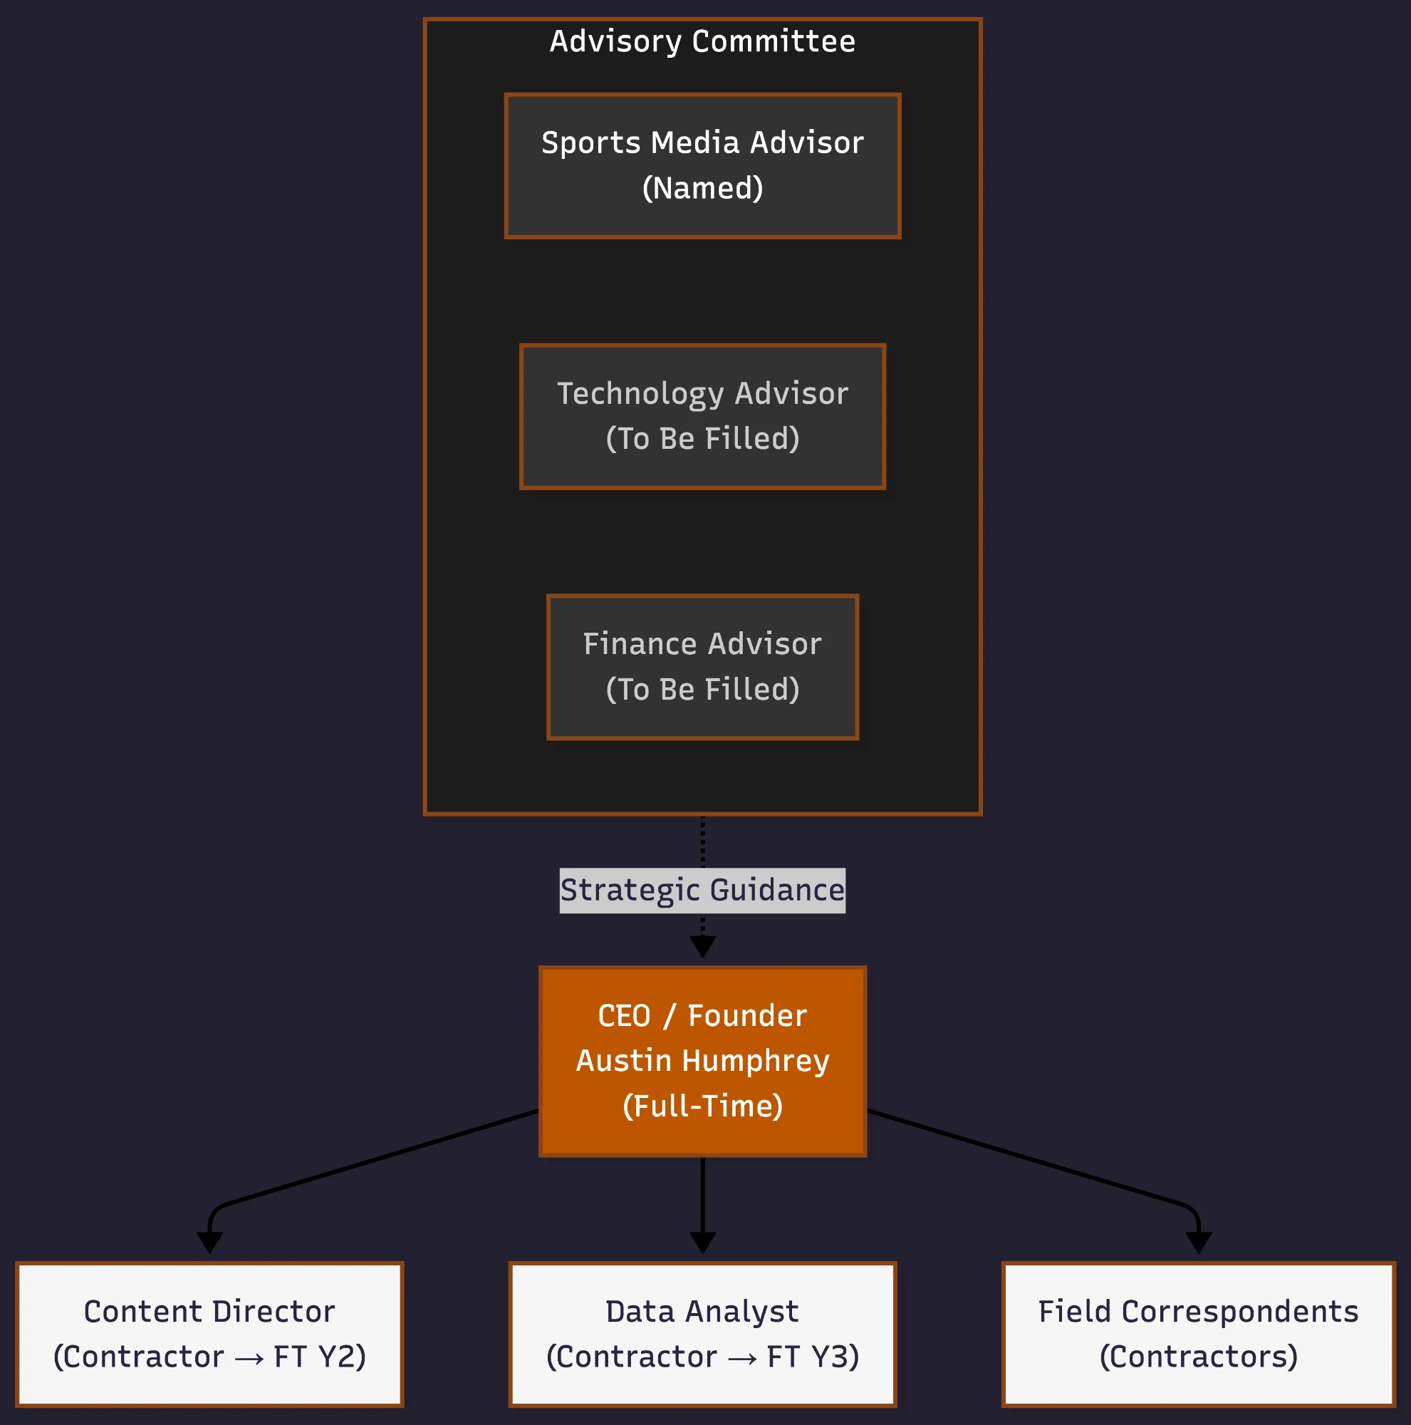
Figure 8.1: BSI Organizational Structure

8.9 EBMS Course Integration
This business plan integrates concepts from multiple EBMS courses:
AEL (Agile Enterprise Leadership): Lean startup methodology informs BSI's iterative development approach, minimum viable product strategy, and resource optimization. The contractor-to-employee staffing model reflects agile principles of proving value before scaling commitment.
PTM (Product & Technology Management): Technology selection criteria, phased implementation planning, and build-vs-buy analysis derive directly from PTM frameworks. The three-phase technology roadmap demonstrates systematic product evolution.
NDM (Negotiation and Deal-Making): Contractor agreements, advisory committee relationships, and partnership structures reflect NDM principles of flexible deal structures and relationship-first negotiation.
DMK (Digital Marketing): Marketing budget allocation, digital customer acquisition strategy, and content distribution channels apply DMK frameworks for audience targeting and conversion optimization.
BSB (Business Strategy & Budget): Revenue modeling, cost control mechanisms, and three-year financial projections demonstrate BSB principles of sustainable business model design.
MPD (Media Product Development): The platform's feature roadmap, user experience priorities, and content production workflows reflect MPD methodology for building media products that serve audience needs.

References
Blaze Sports Intel. (2025). Platform and company information. Retrieved December 10, 2025, from https://blazesportsintel.com
Cloudflare, Inc. (2025). Workers platform pricing. Retrieved December 10, 2025, from https://developers.cloudflare.com/workers/platform/pricing
CommercialCafe. (2024). San Antonio office price per sqft and office market trends. Retrieved December 10, 2025, from https://www.commercialcafe.com/office-market-trends/us/tx/bexar-county/san-antonio/
Growthink. (n.d.). How to write a business plan: Management team section. Retrieved December 10, 2025, from https://www.growthink.com/businessplan/help-center/management-team
Partners Real Estate. (2024). San Antonio office Q2 2024: Quarterly market report. Retrieved December 10, 2025, from https://partnersrealestate.com/research/san-antonio-office-q2-2024-quarterly-market-report/

